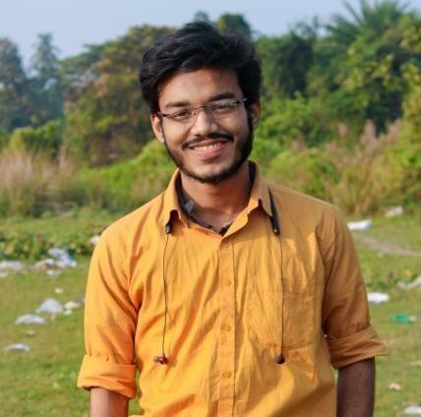

ANIK DUTTA

# ABOUT

I AM ANIK DUTTA. CURRENTLY I AM PURSUING B. TECH IN CSE FROM SISTER NIVEDITA UNIVERSITY. CURRENTLY I AM LEARNING **ADVANCE DSA.** I HAVE STARTED MY COMPETITIVE PROGRAMMING FROM JUNE,2022. I AM INTERESTED IN **WEB DEVOLOPMENT**. I HAVE **5 STARS** IN C PROGRAMMING IN HACKERRANK.I AM COMFORTABLE WITH LINUX.

# CONTACTS

**PHONE-** +916290775604

**EMAIL**: [anikdutta0810@gmail.com](mailto:anikdutta0810@gmail.com)

**ADDRESS**- OLD KAPASDANGA, PIN-712103,

P.O & Dist.- HOOGHLY, WEST BENGAL

# PROFILES

GIT HUB – [anik0810](https://github.com/anik0810)

CODE CHEF – [anik0810](https://www.codechef.com/users/anik0810)

LINKED IN – [Anik Dutta](https://www.linkedin.com/in/anik-dutta-86526021b/)

HACKER RANK- [anikdutta0810](https://www.hackerrank.com/anikdutta0810)

PORT FOLIO - [**https://anik-coder.in/**](https://anik-coder.in/)

# LANGUAGES & SKILLS

* **DSA WITH C++**
* **JAVA SCRIPT**
* **REACT JS**
* **HTML5, CSS3**
* **NODE JS**
* **SASS, SCSS**

**PROJECTS**

* **E-COMMERCE WEBSITE WITH MERN STACK –** [**Adventurous Essence, package tour operator with online booking system.**](https://adventurous-essence.in/)
* **PORTFOLIO WITH REACT JS -** [**https://anik-coder.in/**](https://anik-coder.in/)
* **CONSOLE GAME WITH C++ -** [**Car Race Game**](https://github.com/anik0810/Car-Game) **(in Development State)**

**CERTIFICATES & ACHIEVEMENTS**

* [**JAVA SCRIPT CERTIFICATION BY HACKER RANK**](https://www.hackerrank.com/certificates/aab8037b33fa)
* [**CSS CERTIFICATION BY HACKER RANK**](https://www.hackerrank.com/certificates/d5a50db5a5d0)
* [**CERTICATE ON PROBLEM SOLVING SKILL**](https://www.hackerrank.com/certificates/c700975be72d)

**EDUCATION**

## HIGHER SECONDARY EDUCATION - HOOGLY BRANCH (GOVT.) SCHOOL

**MARKS-93.43%**

**B. TECH - CSE ||SISTER NIVEDITA UNIVERSITY|| PASSOUT YEAR -2024**

**CGPA-9.00**